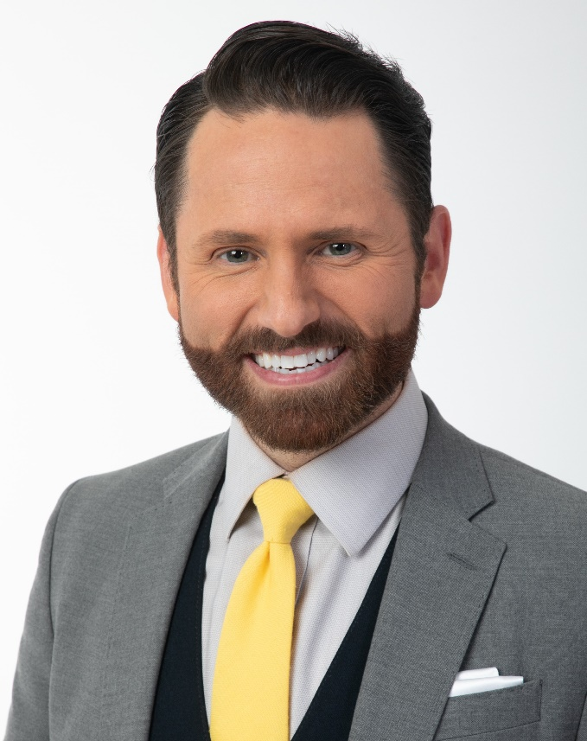 |  |  | Experience  January 2021 – Present  WZZM Morning News Anchor  - Anchor live morning broadcasts  - Shoot, write, and edit weekly segments  - Mentor colleagues on creative writing, teleprompter usage, and breaking news coverage  October 2018 – July 2020  WXIA News Reporter  - Reported on current events for daily broadcasts  - Successfully launched MyNews digital platform  - Shot, wrote, and edited daily news reports  June 2013 – August 2016  KFSM Morning News Anchor  - Anchored live morning broadcasts  - Shot, wrote, and edited weekly segments  - Mentored colleagues on creative writing, teleprompter usage, and breaking news coverage  January 2011 – May 2013  KHOG Weekend News Anchor  - Produced and anchored live broadcasts  - Shot, wrote, and edited daily news reports  February 2008 – December 2010  KMID News Anchor/Reporter  - Shot, wrote, produced, and anchored daily live broadcasts  - Shot, wrote, and edited daily news reports  Education  May 2007  Marshall University  Huntington, WV  B.A. in Broadcast Journalism  Honors & Activities  Master of Ceremonies for fundraisers, banquets, and concerts; Keynote Speaker for community events; Spokesperson for a variety of initiatives including annual Scouting for Food drive; Corresponding Secretary and Social Chair of Kappa Alpha Order; VP of Delta Epsilon Chi; Eagle Scout

Jay

Plyburn
 | 304-638-5641
 | jayplyburn@gmail.com
 | Grand Rapids, MI
Overview
Charismatic entertainer and media representative who is an accomplished public speaker with extraordinary verbal and written communication skills. Detail-oriented journalist with a flair for creativity offering expertise in writing, filming, and editing original content. Persuasive team builder and natural leader who proactively plans out and executes business improvement strategies. Consistently delivers strong financial results through strategic brand management.

