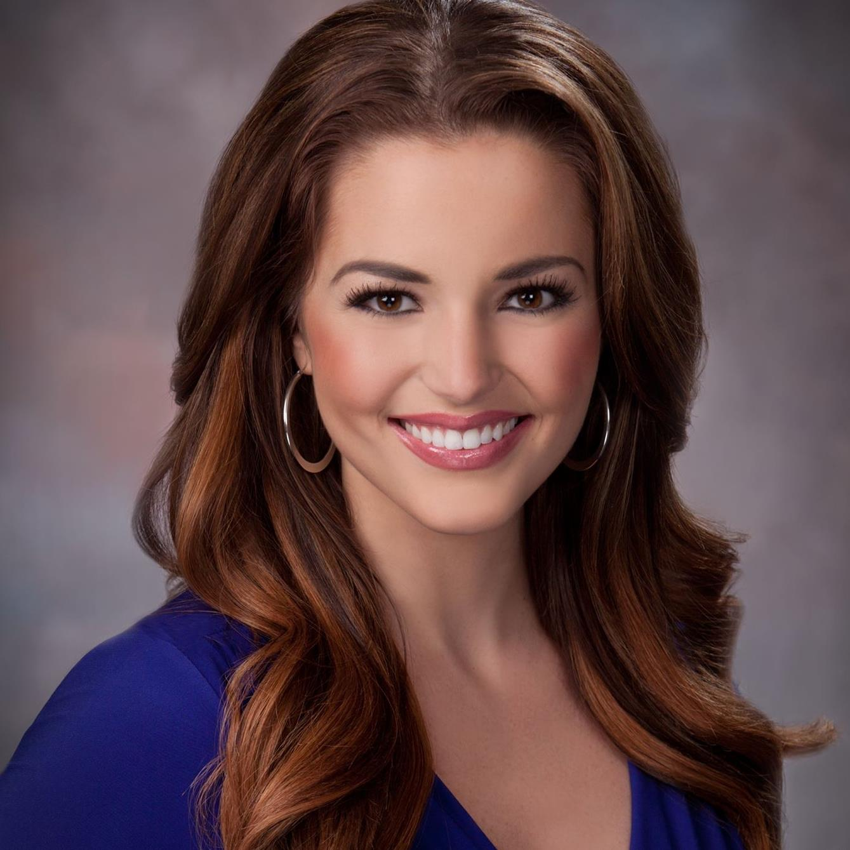
CAROLI NE COLLINS

116 Clubhouse Circle
West Middlesex, PA 16159
collinscarolineb@gmail.com
724-974-8177

OBJECTIVE

To break and tell stories in a top ranked news market.

EDUCATION

Point Park University May, 2019
• Master of Arts in Communication Technology, Concentration: Social Media
• Bachelor’s Degree On- Camera Broadcasting, Magna Cum Laude 2015

EXPERIENCE

WFMJ Weekend Evening Anchor and Reporter - Current
• Solo anchor of weekend evening newscasts; Multi Media Journalist, shoot and edit all stories under tight deadline;
weekday fill-in anchor morning and evening shows; MMJ breaking news live shots; cover multiple stories and often turn
two packages during each shift; banter and ad-lib frequently; regular Facebook Live reports and social media updates; co-
produce and video edit evening newscasts; top social media influencer in local news market. Reported on and anchored
coverage of stories that gained national attention including the shooting death of a Girard, Ohio police officer and the
closure of GM Lordstown.

National Golf Show Co-Host - Current
• Co-host of The Swing Clinic, a golf show airing nationally reaching more than a million viewers. Ad-lib segments with
PGA Golf Professional; explain and demonstrate golf shots while bantering and interacting with co-host, Jimmy Hanlin;
work with large film crew to produce entertaining and informative segments; orchestrate engaging social media content.

WJET/ WFXP General Assignment Night Side Reporter / Fill- in Anchor / Producer - June, 2015- 2016
• Excellent breaking live shot reporter; fill- in anchor and producer for 3 hour newscasts; completed packages and several
VO/SOTs each shift; social media engagement at breaking scenes including Facebook Live and Twitter; enterprised
innovative and new story ideas; conducted thorough interviews; exhibited fast and diligent writing skills; produced all
website content for stories; well versed in local and national politics; built relationships within the community; performed
well under pressure. Reported on the 2016 election and interviewed then Vice Presidential Candidate, Mike Pence, the night
before the election.

Chair Shot Reality Host and Reporter – October, 2013 - 2015
• Hosted the hit show on Wrestlezone.com reaching more than 60,000 viewers each week; performed entertainment
segments about WWE wrestling; traveled around USA to WWE events as a Chair Shot Reality reporter.

Docherty Agency TV Spokesperson and Model - 2010- 2019
• Latrobe Chevrolet and Ford TV commercial Spokesperson; face of Eyetique TV commercials; featured as the voice
and face of international companies including Dick’s Sporting Goods, Fisher-Price, Rue 21, American Greetings,
Slazenger Golf, Golf Galaxy, US ABE Uniform, Eyes of Faith, Werner Ladders, Jo- Ann Fabric and Craft Store and more.

SKILLS
• Experienced in editing with Grass Valley Edius, Final Cut Pro and Adobe Premiere; excellent in videography, operates Sony
news cameras; shoots solo live shots with camera and live backpack. Certified in social media and digital marketing
courses. Social media savvy with Instagram, Facebook, Twitter, and YouTube. Strong website writer. Well versed in
website publishing systems. Experience with ENPS and iNews. Strong story teller, broadcast writer and interviewer.

COMMUNITY SERVICE/ HONORS AND AWARDS
• Full Golf Scholarship to Point Park University; raised more than $20,000 for the Folds of Honor Foundation; host of
Golf for Patriots Outings and Run for Patriots 5k; Children’s Miracle Network fundraiser; Master of Ceremonies and
Keynote speaker at many charity events in Youngstown, OH including American Heart Association’s Heart Ball.

