Bode Brooks
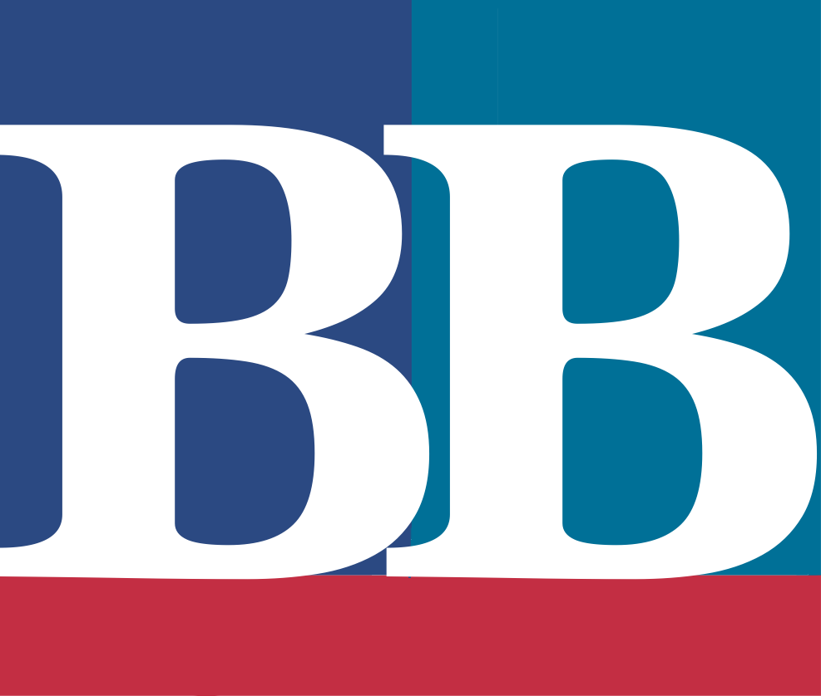
Represented by: TV Talent Agents, Inc. Paul Brewer
paul.brewer11@comcast.net
706.
836.5290

Represented by: TV Talent Agents, Inc. Paul Brewer

paul.brewer11@comcast.net 706.836.5290

Work History
KTVE – KARD, West Monroe, LA | Nexstar Media Group
Weekday Evening Anchor
November 2019-Present
- Co-anchor three 30-minute newscasts
- Produce the 10PM newscast
- Lead station political coverage and special events
Weekday Morning Anchor
May 2019-November 2019
- Co-anchor and produce 50% of 4-hour newscast
- Manage and schedule daily show guests
- Produce special assignments or field report as needed
95.5 WSB, Atlanta, GA | Cox Media Group
Weekend Anchor
September 2018-May 2019
- Produced and anchored 12 live newscasts per shift
- Consulted with news director for general coverage plans
- Packaged stories to air after anchor shift.
Radio News Intern
May 2018-August 2018
Audible, Inc. | Amazon.com, Inc.
Narrator (Independent Contractor)
Feb 2018-April 2019
- Produced and edited full length text in accordance with Audible quality standards.
- Coordinated with book rights holders on production details and deadlines.
WZQZ AM 1180, Summerville, GA
News Reporter/On-Air Personality
Oct 2013-Aug 2015
- Anchored six daily five-minute newscasts.
- Produced local news stories, commercial spots, and promotions.

Honors and Activities
Georgia Association of Broadcasters
- GABBY – Best Team Political Coverage, WSB, 2019
National Broadcasting Society – Alpha Epsilon Rho
- National Undergraduate Student Electronic Media Competition, Audio News Package, 1st Place, 2019
Broadcast Education Association
- International Festival of Media Arts, Hard News Reporting, 2nd Place, 2018, 2019
College Broadcasters, Inc.
- National Student Production Award, Best News Reporting, Finalist, 2018
Intercollegiate Broadcasting System
- Best Spot News Coverage, Winner 2018, 2019
- Best News Director Finalist, 2017, 2018, 2019
- Best News Feature Finalist, 2018
- Best Spot News Story Finalist, 2019
Technical Skills
- Avid iNEWS
- Newsboss V6.3
- WideOrbit Radio Automation Software
- Adobe Audition 1.5-CS6
- Adobe Premier Pro
- Ross Inception News
- Basic WordPress

Education
University of West Georgia, Carrollton, GA
Bachelor of Science in Mass Communications
Cum Laude - Spring 2019

